



Contents

Button Customization 6

# Part 1

## Introduction

### Playstationhax.it Dev Net

Hi guys I thought of making a few Tutorials for you guys to get you started on a few C# applications

So I created this app you can download it on my GitHub

<https://github.com/xXxTheDarkprogramerxXx>

Things you will need:

* Visual Studios Community (or any other version I use Professional/Ultimate)
* A passion for coding ^^

## Getting to know Visual Studios

### The First time

So opening visual studios for the first time it might seem overwhelming as hell to see all this stuff on the window open up but as time goes on you will get to master all of these components and even how to use them to their max

Opening the project you will get created by this window

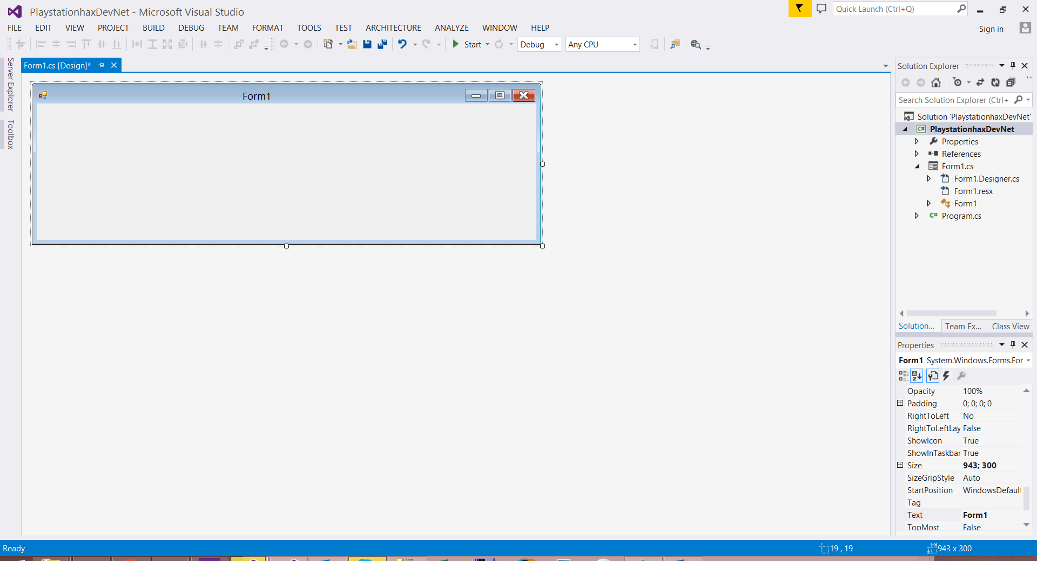

As you can see it has the main Form in the middle of the screen and to your left you have a few tabs one of them you will use a lot is the Properties Window

### Solutions Explorer

The Solutions Explorer is a great window and keeps track of all your project components.

For now we can see that the Project is a c# Project and it’s called PlaystationhaxDevNet

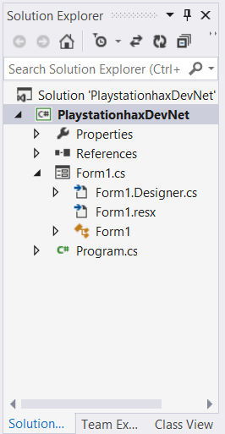

Within this project we will have the following items

* Properties
* References
* Form1
* Program.cs

### The Properties Window

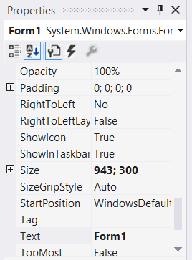

The Properties window contains all the Properties you currently have selected in the main window (where our form is)

For now the Form is selected

You have here a few options on simplifying the layout for yourself

You can either sort the Property window via Category or Alphabetically As you can see mine is sorted alphabetically.

On this window we can also see the Events of the current component

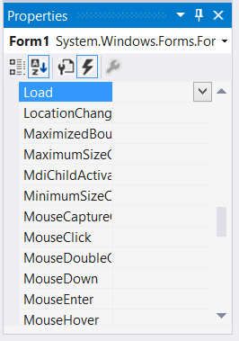

The load event and closing event are used a lot during development

### The Toolbox of Glory

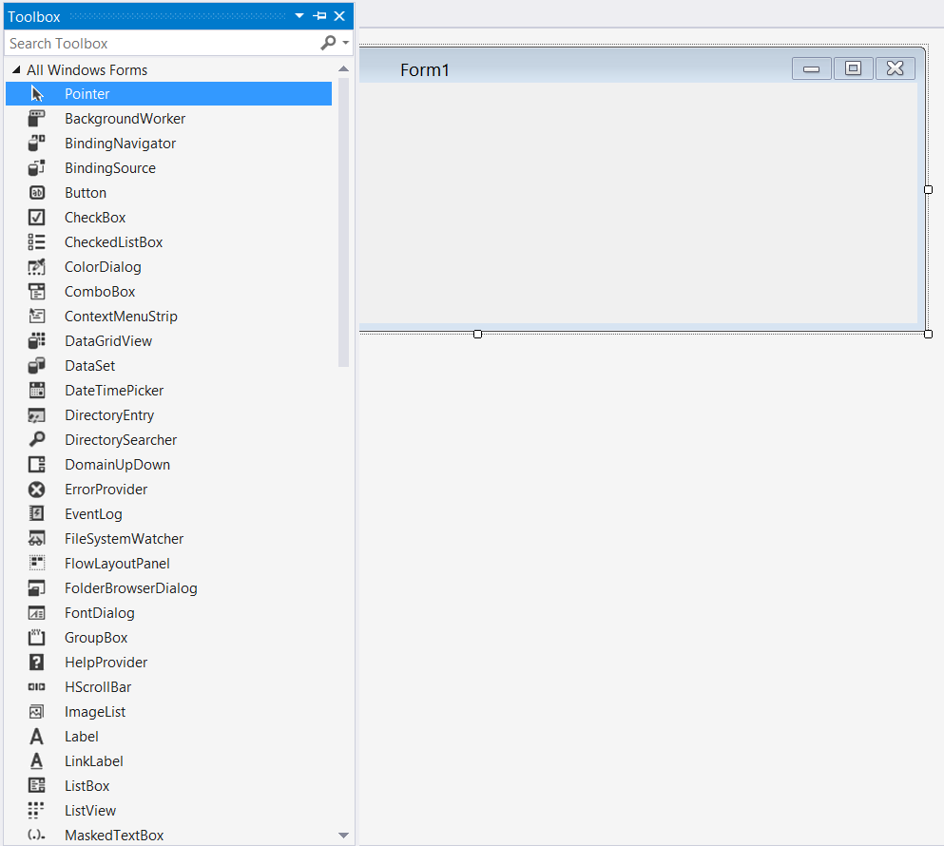

To your left on the screen you should see the Toolbox this little item has all the components you can add onto your project and onto the current form

We can add buttons, List boxes, labels ext. ext.

## Adding a button

So now that you know more or less what’s going on in Visual Studios (I will refer to it most times as VS) lets add a button to the current form

Simply drag and drop the button from the toolbox to the current form.

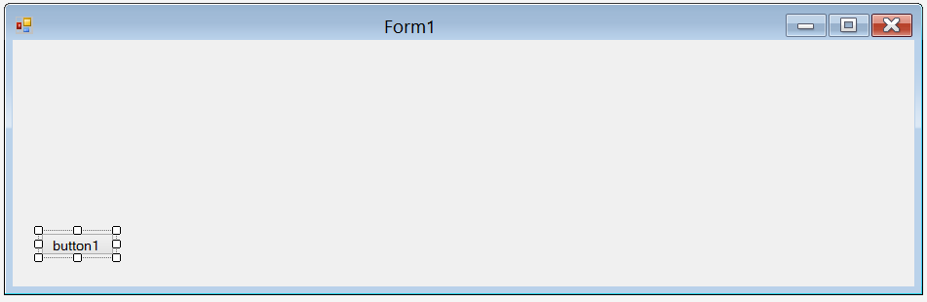

You have successfully added a button to the form

## Editing the button

Now let’s get to edit the Button a bit

Go to your properties window and Give it the following text

Show me

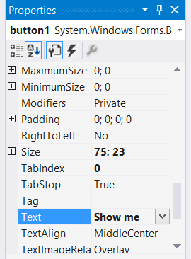

As soon as you press the enter key it will auto change the buttons text to your text as follows



You can change a lot of things in the Properties window for the Button I would suggest keep playing with it see what all the properties do and get to know your components ( the best way to learn is to play with it and break it)

## Writing some code

Now let’s double click on the button to create the button click event.

As you can see a new window has open and we have moved to a new tab which is the code side of the form

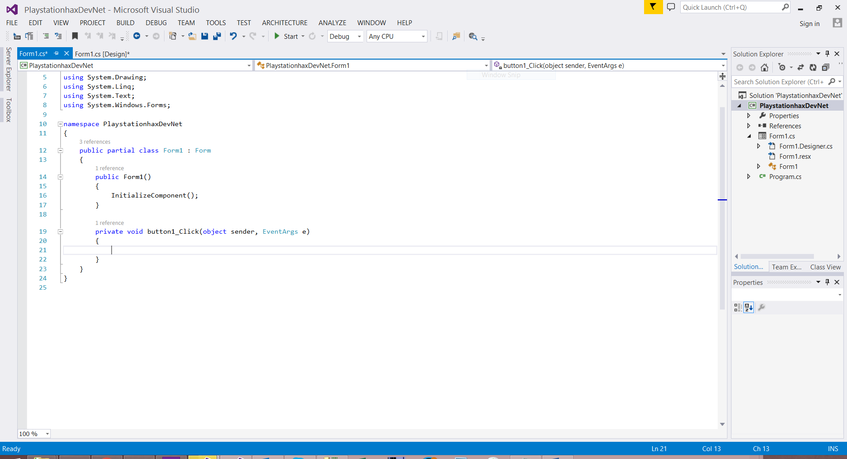

On the top we have the using this is where you reference a namespace ( all of this we will get into later in this tutorial or you might get nosy and use Google)

The we have the Namespace namespace PlaystationhaxDevNet (this is the namespace for our entire Project

You will then see public partial class Form1 : Form

Now this is the main class for the Main Form (Form1 and it is of Type Form)

Now you will see within this class you will see this

public Form1()

{

InitializeComponent();

}

This is the initializing of all the components on the form with all its properties. This will include everything we change in the design view of the form

Finally we have the Button Click event we just added

private void button1_Click(object sender, EventArgs e)

{

}

This is where the code will point to and execute when you click on the button on the main form

Now let’s code.

In the main Button we will add a [MessageBox](https://msdn.microsoft.com/en-us/library/system.windows.forms.messagebox(v=vs.110).aspx)

Please click on the link I supplied MSDN gives allot of useful info when you’re not quite sure what to do

Basic Structure of the messagebox

MessageBox.Show("Your body text comes here");

So we will implement this into the code as following

private void button1_Click(object sender, EventArgs e)

{

MessageBox.Show("Your body text comes here");

}

Now lets build and run the Project just look for this icon



And press it or use the shortcut key (F5)

Now you will see the form launching up click on the button and what happens

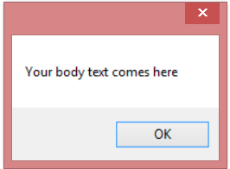

We have a message box and click okay and close the main form now let’s make it look more user-friendly

Back in VS in the Code lets add a more advanced messagebox

MessageBox.Show("Your body text comes here","Your Title Text Comes Here",MessageBoxButtons.OKCancel,MessageBoxIcon.Information);

Change the Messagebox to the following in the Button Click Event

See what happens when you build and run it now customize the button to suite your needs

MessageBox.Show("Hello World !","PlaystationHax.it DevNet",MessageBoxButtons.OKCancel,MessageBoxIcon.Information);

## Adding a new form

Go to the solution explorer and right click on the Project itself

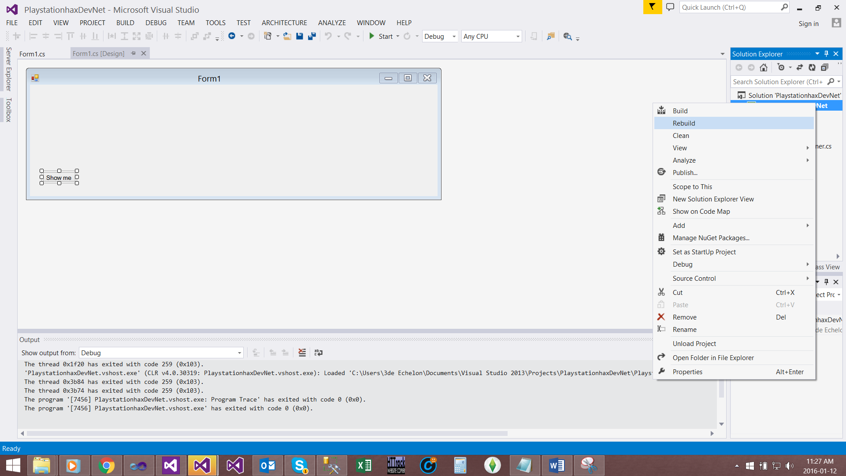

Now say Add and from here you can select either add new item and go via that and select a windows form or just select windows form from the list

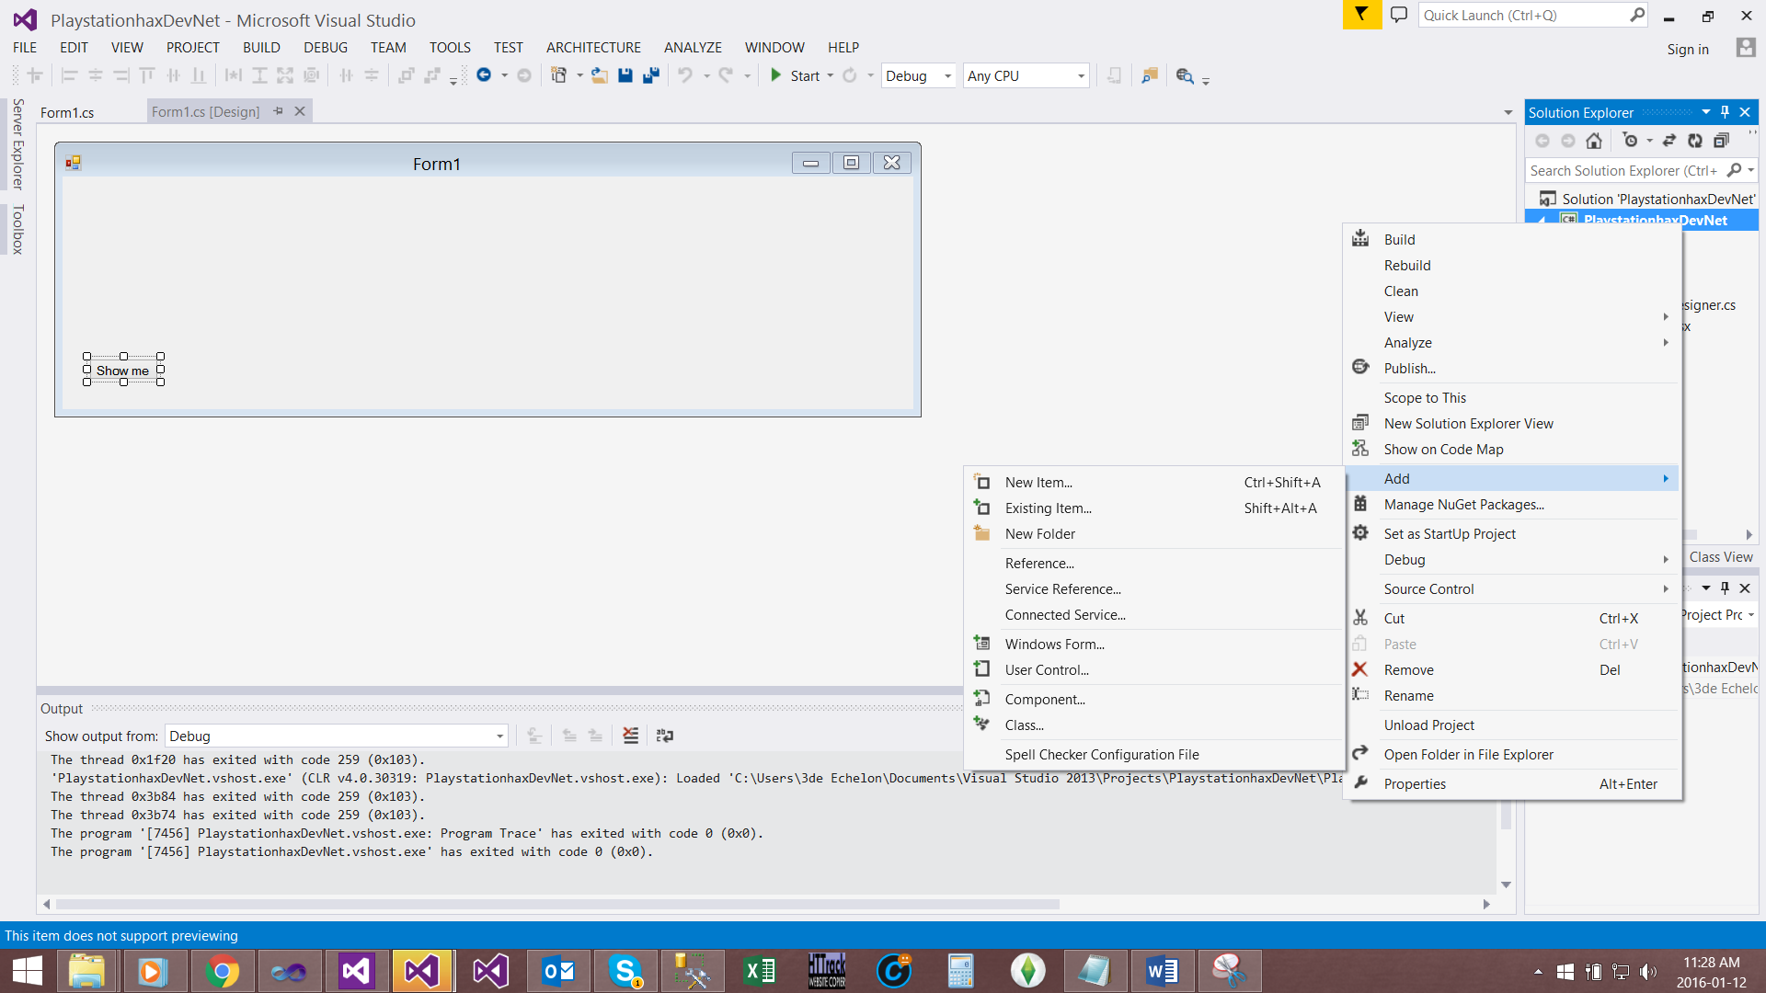

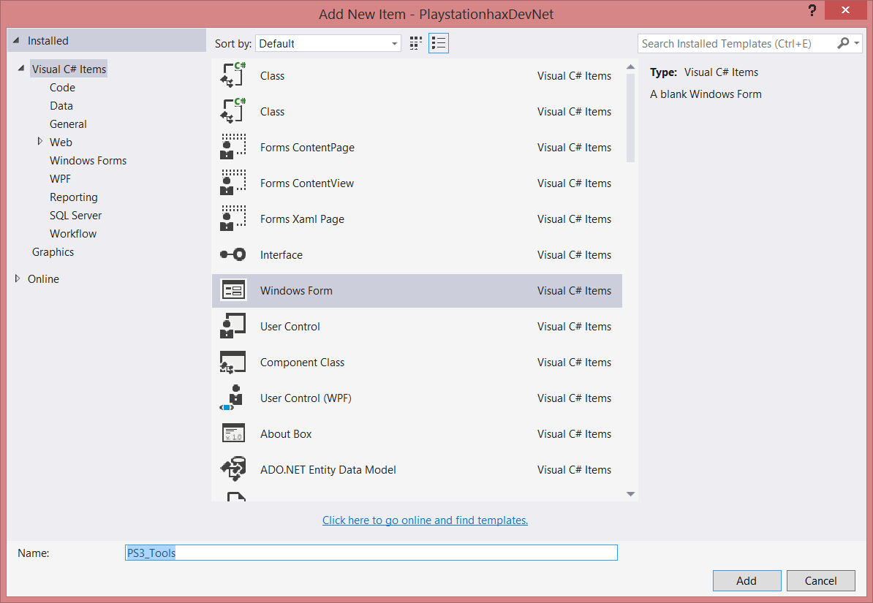

Give it a name PS3_Tools (we are goanna develop some simple ps3 tools later)

As soon as you have added the new Form it will show up on the Design window and also be added to the solution explorer

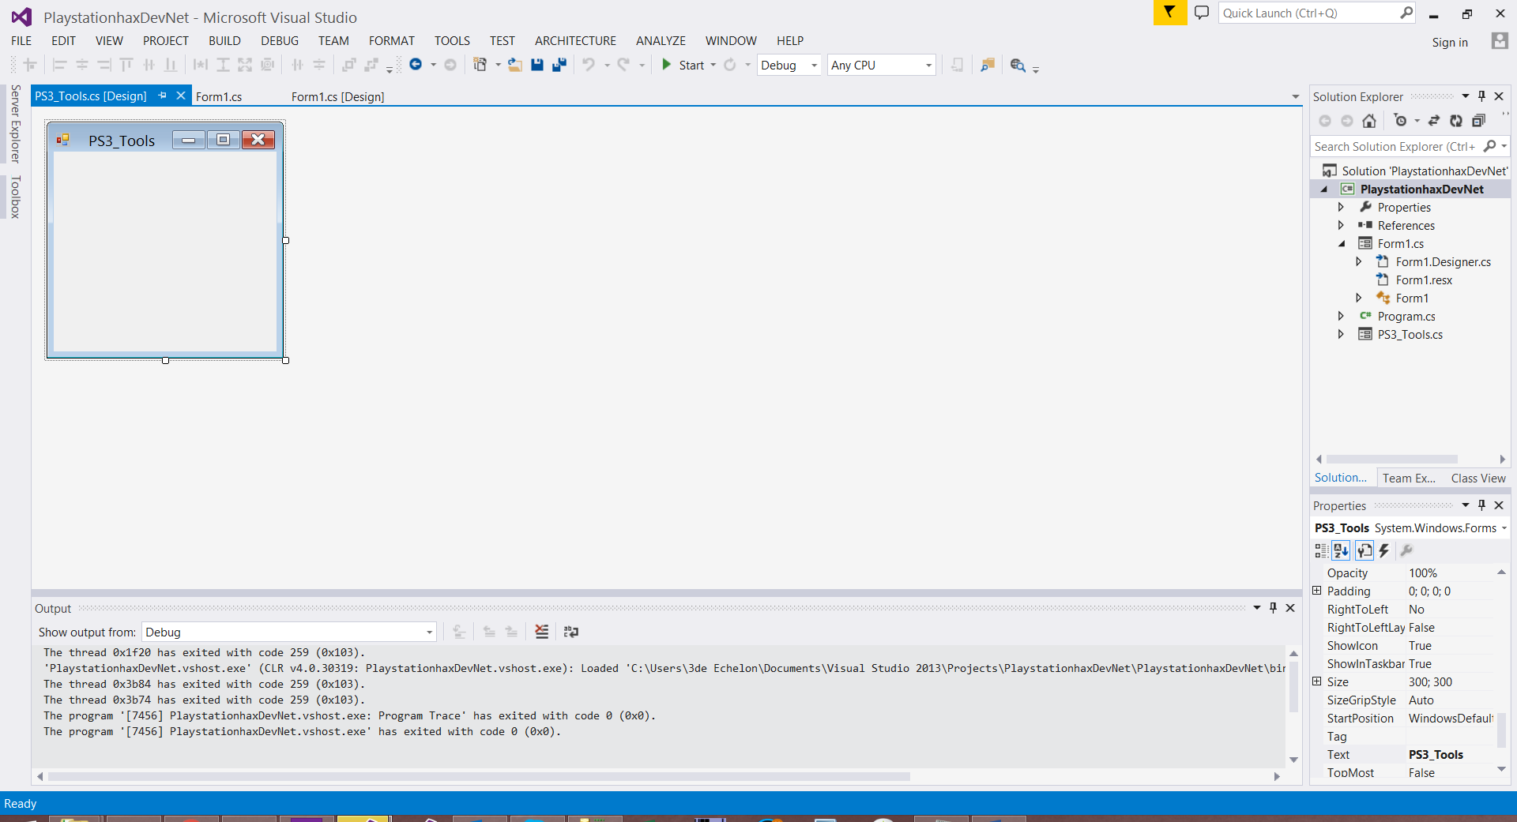

## Adding A picturebox

Now we will add a picturebox for the Tool This will display our logo for the tool

Go to Toolbox and drag in a picturebox

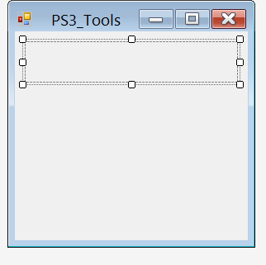

Now we can do the image a couple of ways but all of them include the Properties window

Firstly we need to add the image to the resources

To do this simply click on the … in the properties Windows’s background image filed



This will open the resource manager

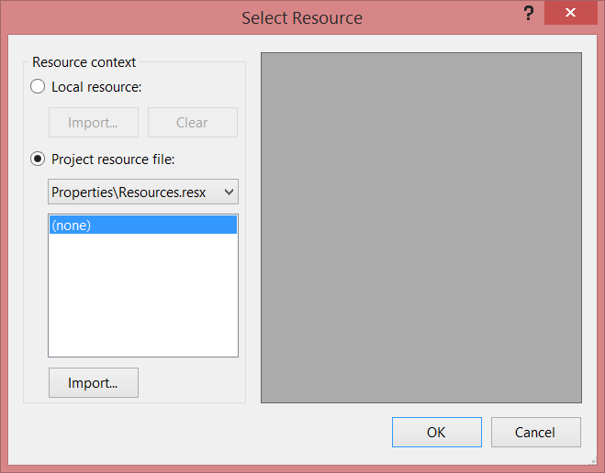

Now because I like working with the resource folder and its less sloppy to use it we will just be using that in this Tutorial

But you can however locally import it to the project but I would highly advise you not to do it this way

So let’s say import

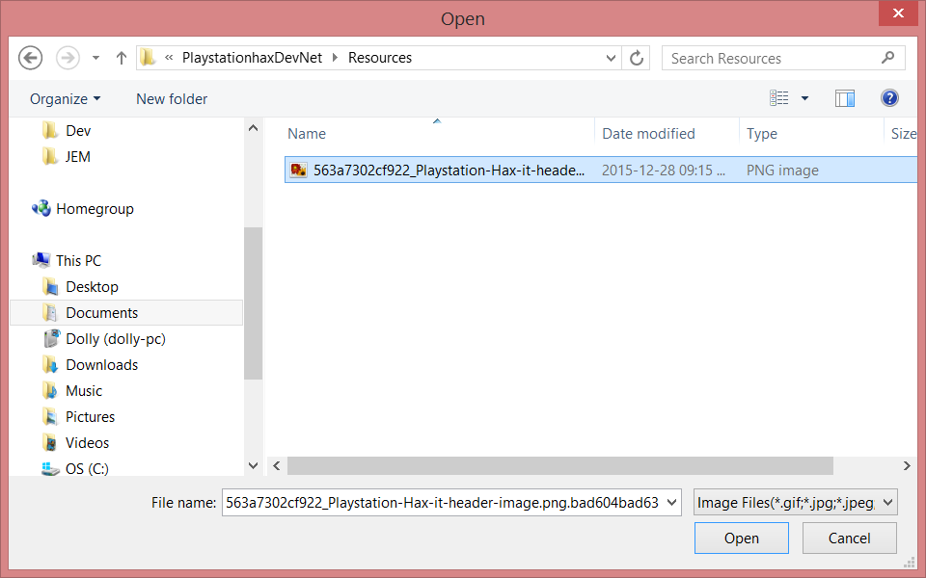

Locate an image (for the Picturebox we use images )

Make sure it’s the correct image

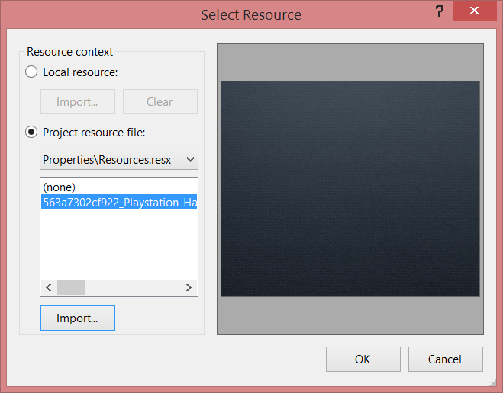

And simply click OK

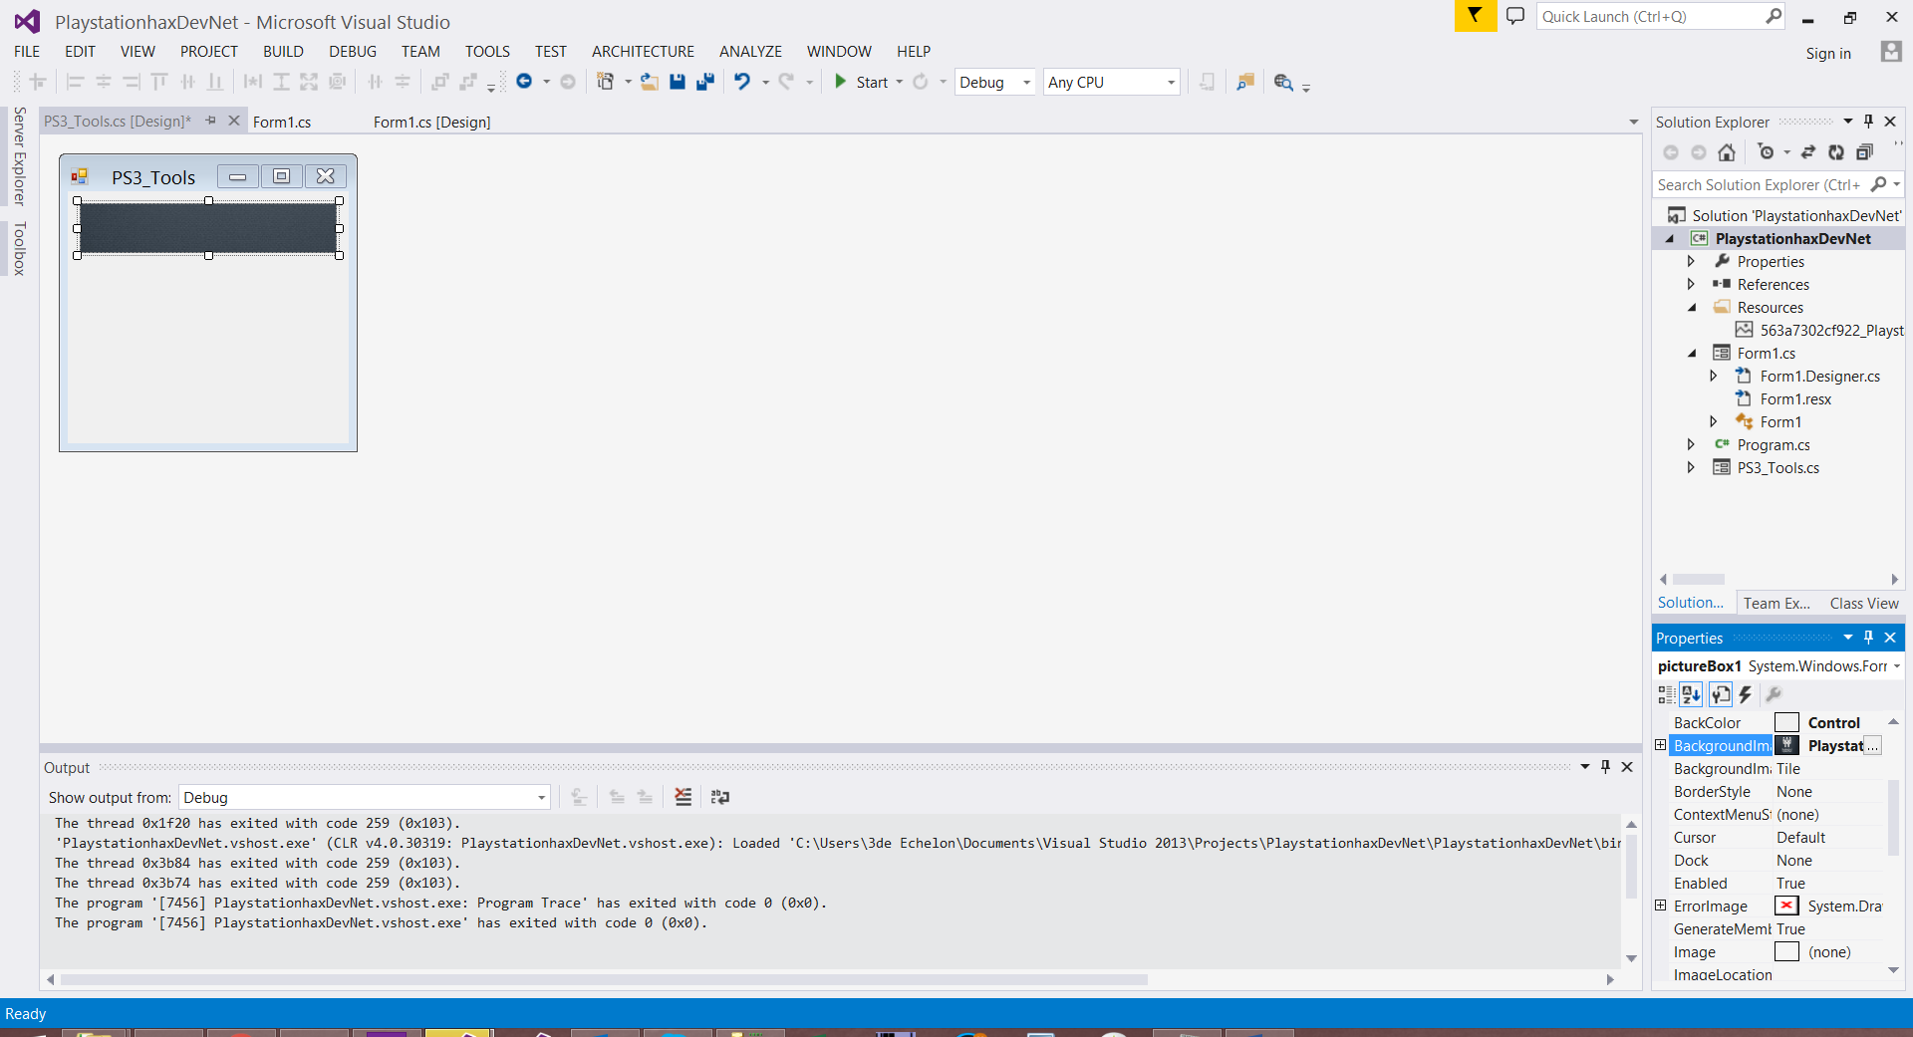

As you can see it now changed the picturebox image and the properties field has been updated as well

But it looks pretty squashed up

So how we fix this is by changing the background image Layout to zoom stretch just makes it look messed up



Now the image should be perfect

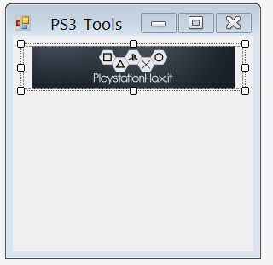

## Commenting and Uncommenting Code

Commenting in code is one of the best ways to help the next developer to understand what exactly is going on in code

There are a few comment styles

1.

/* this is

* a

* long

*

* comment */

2. //this is a short comment

Commenting code lets go back to Form1 and comment some code

In the button click event

Add the following comments to the code

private void button1_Click(object sender, EventArgs e)

{

//This is our message box

MessageBox.Show("Your body text comes here","Your Title Text Comes Here",MessageBoxButtons.OKCancel,MessageBoxIcon.Information);

/* next we will navigate forms */

}

Now we want to comment that messagebox out either manually add // infront of the messagebox or look for this in your toolstrip





this will comment the current line which has your cursor on it

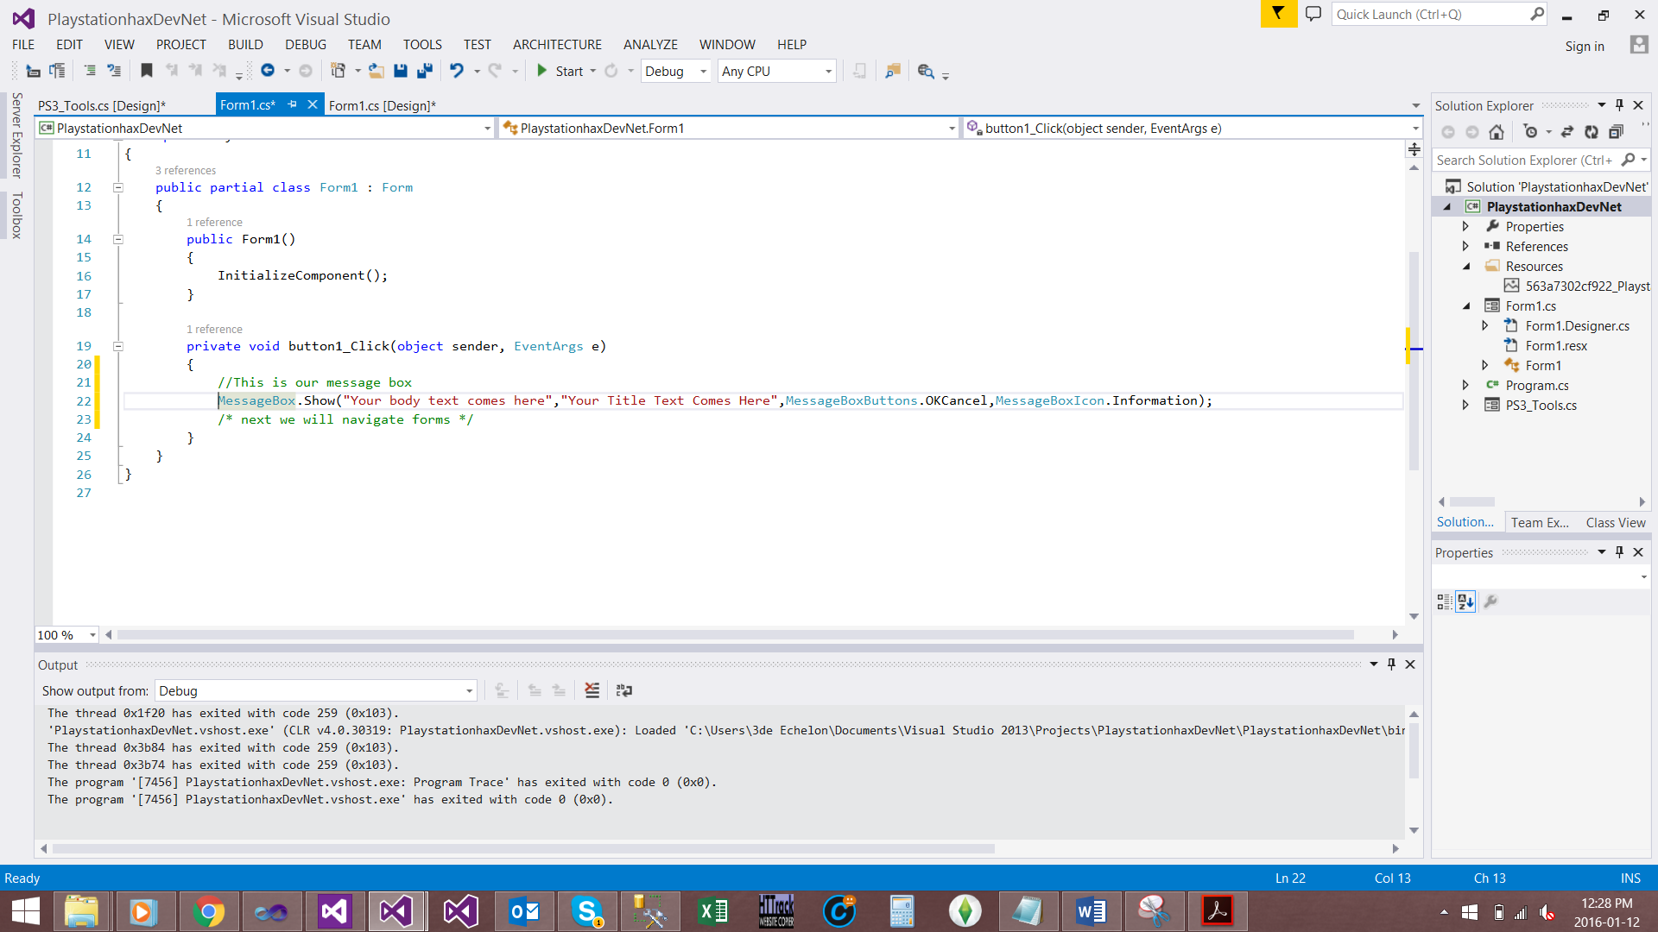

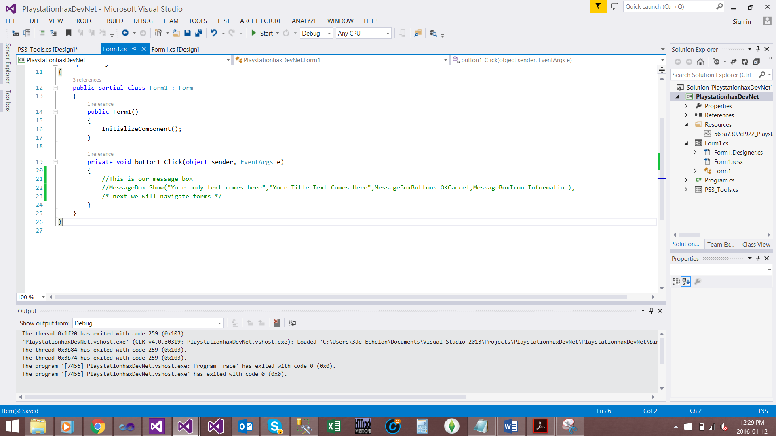

## Navigating forms

In the button click event for Form1 we will navigate to the PS3_tools Form

To do this add a reference to the Form and call it with ShowDialog();

e.g.

//This is how we reference

MyFormName formy = new MyFormName();

//this is how we show

Formy.ShowDialog();

So the code in this project will be

//this is how we reference

PS3_Tools ps3 = new PS3_Tools();

//this is how we show

ps3.ShowDialog();

if you click on the button now it will navigate from the Main Form To Our New Form PS3_tools Form

That’s the End of Part1